While payments led the first part of the fintech journey and will remain the largest fintech segment in 2030 growing fivefold to $520 billion, the report's authors believe B2B2X (business-to-business-to-any-user) and B2b (serving small businesses) will lead the next era.

B2b fintech revenues are projected to grow at a 32% CAGR to become a $285 billion market by 2030. There are roughly 40 million small to mid-sized enterprises (SMEs) in Nigeria, and more than 400 million in total globally. In Africa, SMEs provide over 80% of all jobs across the continent – showcasing the enormous opportunity for growth for fintech’s in this space. Meanwhile the B2B2X market is expected to grow at a 25% CAGR to reach $440 billion in annual revenues by 2030, supported by growth in embedded finance and financial infrastructure.

"We are in the early stages of a 25-year (or longer) growth journey, and the opportunities for growth, particularly in emerging markets like Africa, are only just gathering momentum," concluded Anteghini.

Digital payments

The **fastest-growing regions**in the digital payments market will be **South America and Africa** where growth during 2025-2030 will be at **CAGRs of 15.6% and 12.6%** respectively. These will be followed by the Middle East and Eastern Europe, where the markets are expected to grow at CAGRs of 12.0% and 11.5% respectively.

The African electronic payments market is worth ~$18 billion in revenues. Domestic payments account for ~$8 billion within the same amount. The online payments market is worth $0.8 billion and represents ~10% of the electronic payments market. In 2018, the total online payments revenue was driven by a mix of both cards as well as mobile money revenue. Both debit and credit card payments accounted for 56% of the revenue generated as compared to 26% brought in by mobile money and 18% brought in by electronic money transfers. The volume of payments was concentrated on both card and mobile payments at 42%.

(Patat, *Why Africa has the future of payments*)

(Moloko et al., *Africa's fintech boom: Fastest-growing region* 2023)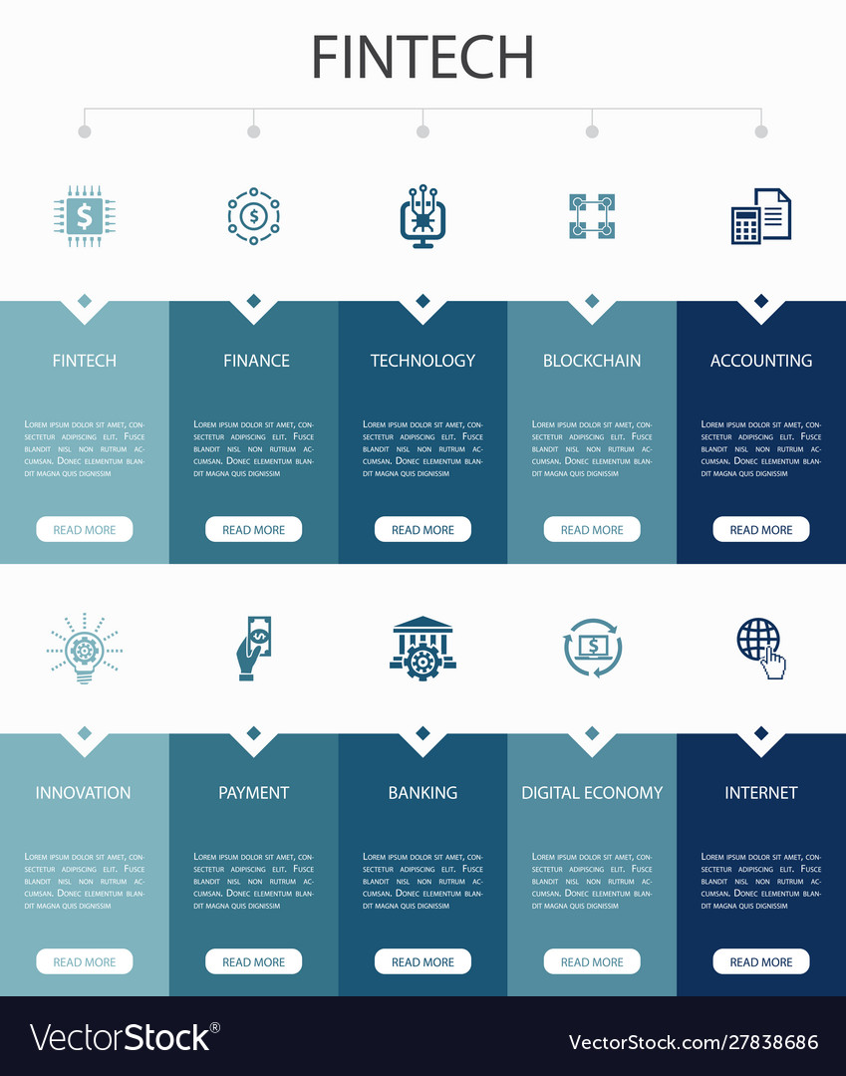

<https://www.vectorstock.com/royalty-free-vector/fintech-financial-technology-infographic-elements->vector-27785252

<https://bfaglobal.com/catalyst-fund/insights/talent-program-infographic/>

https://www.codemotion.com/magazine/infographics/key-skills-for-fintech-developers-codemotion-magazine/

<https://www.connectingafrica.com/author.asp?section_id=761&doc_id=785608#:~:text=Africa%20is%20set%20to%20be,(BCG)%20and%20QED%20Investors>.

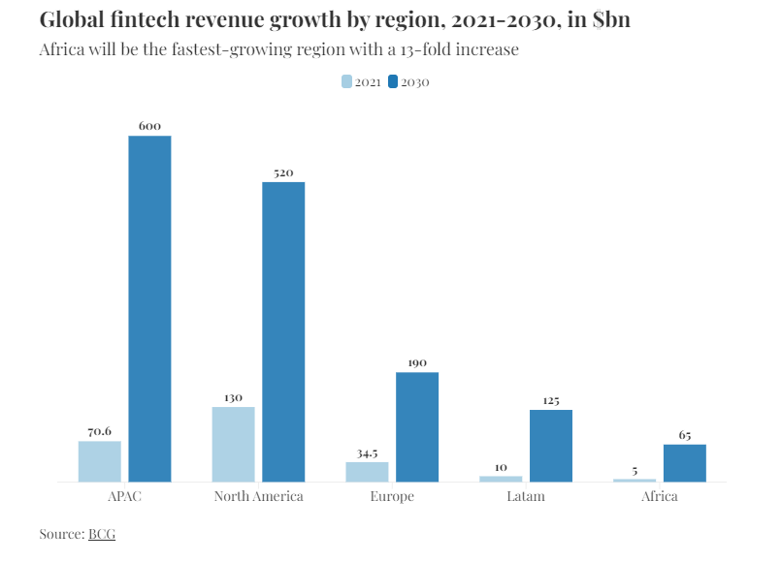

<https://african.business/2023/06/technology-information/africas-fintech-market-to-reach-65bn-in-revenue-by-2030-says-new-study#:~:text=According%20to%20the%20New%2DYork,disruption%20in%20the%20long%20run>.

<https://www.statista.com/outlook/dmo/fintech/africa#analyst-opinion>

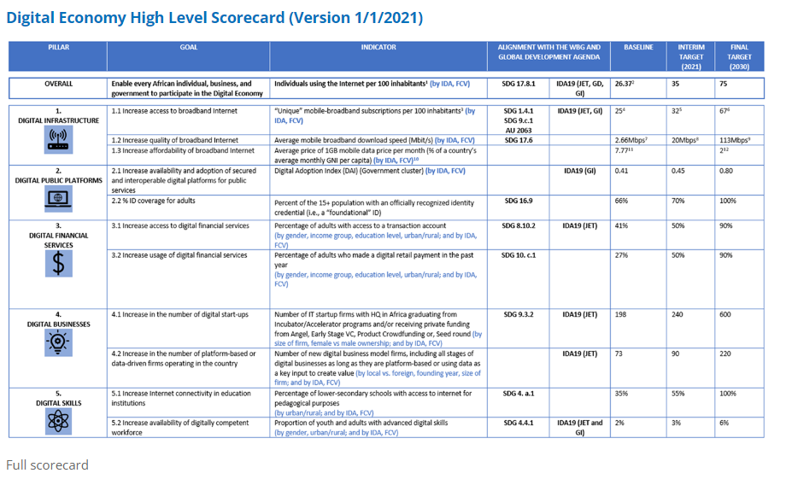

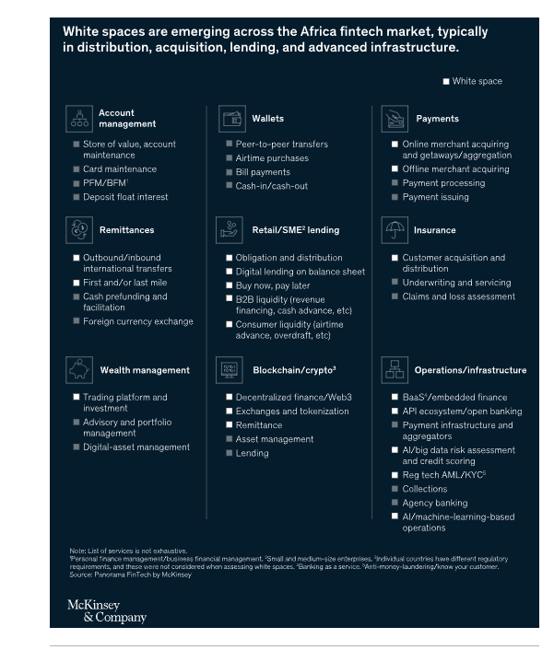

https://www.mckinsey.com/industries/financial-services/our-insights/fintech-in-africa-the-end-of-the-beginning

Motion infographics

Uses motion

Captures attention

Enhanced engagement

Simplify complex ideas

It represents a collaborative effort to harness the transformative power of financial technology to drive economic growth and prosperity across the African continent.

Key areas:

Digital payments and mobile banking

Lending and peer-to-peer financing

Cryptocurrencies and Blockchain

Robo-Advisory and Wealth management

Principles:

* Contrast
* Hierarchy
* Alignment
* Repetition
* Typography
* Colour
* Animation Timing
* Transitions

Balancing Aesthetics and Readability:

* Simplicity
* User Experience
* Testing and Iteration

Refining animations

1. Motion infographics
2. FinTech industry
3. How to the FinTech industry applies to the vision 2030

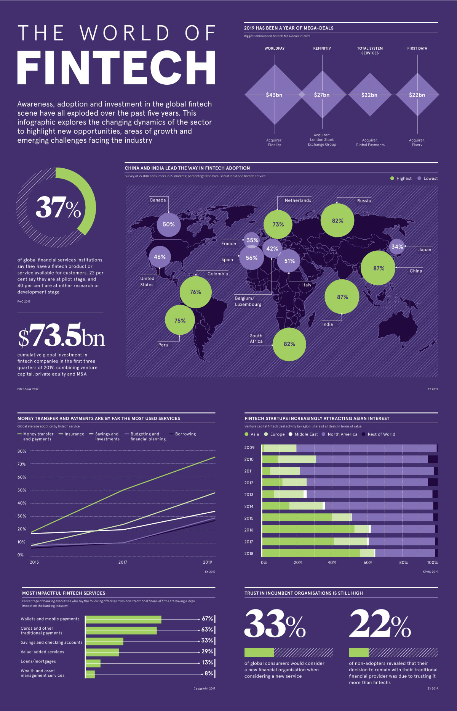

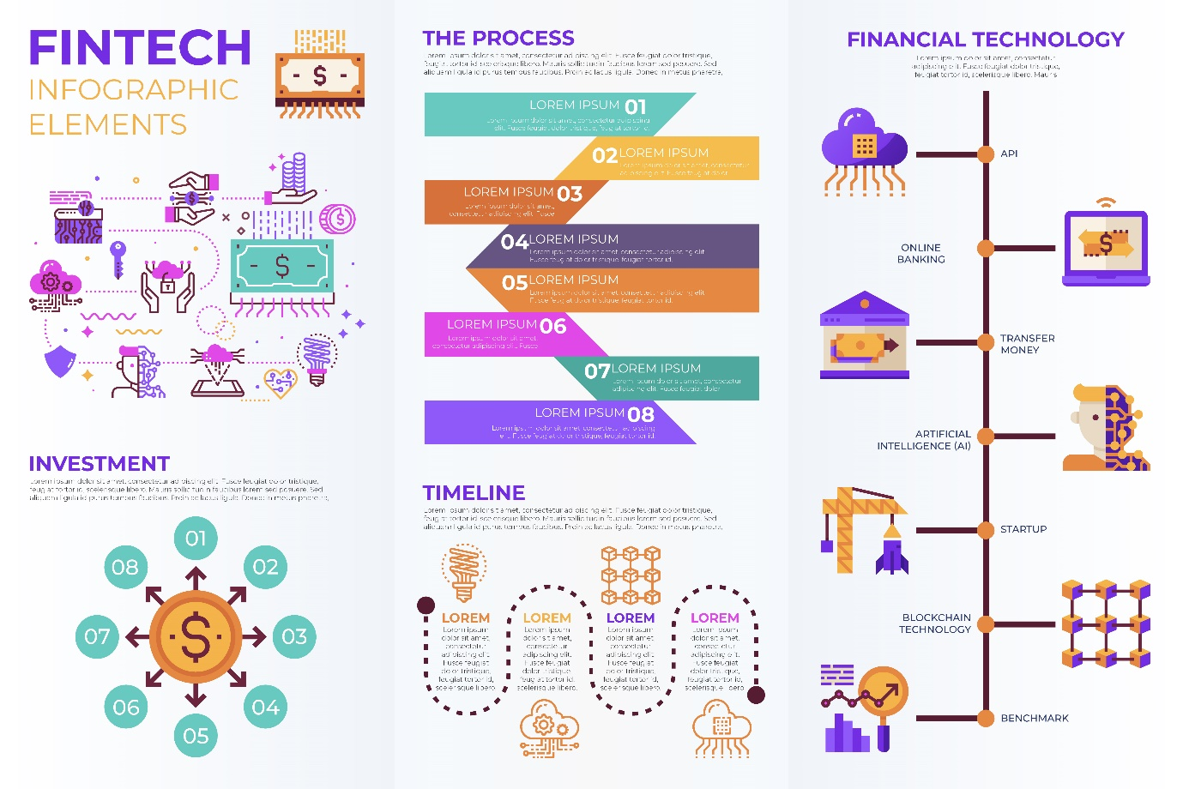

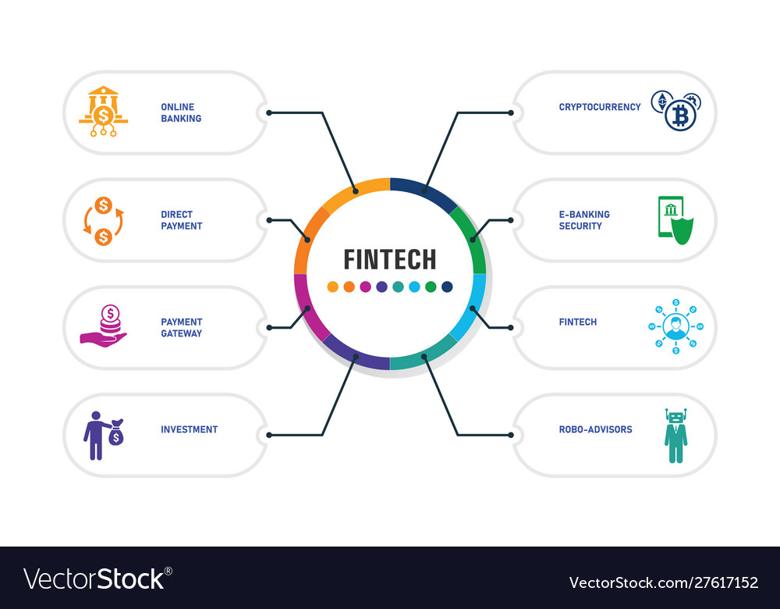

<https://www.vectorstock.com/royalty-free-vector/fintech-infographics-design-timeline-concept-vector-27617152>

<https://www.vectorstock.com/royalty-free-vector/fintech-infographics-design-timeline-concept-vector-27617152>

<https://www.vecteezy.com/vector-art/539818-fintech-financial-technology-infographic-elements>

<https://www.pixtastock.com/illustration/64430189>

<https://qrvey.com/blog/analytics-in-the-new-world-of-fintech-infographic/>

<https://www.linkedin.com/pulse/fintech-africa-driving-much-more-than-financial-yardenne-assa-maor/>

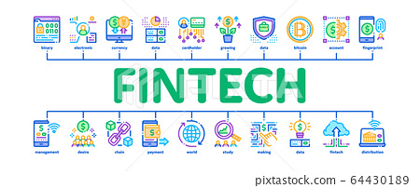

Based on the search results, the key areas that Fintech in Africa will focus on include:

1. **Digital Payments**: Fintech companies in Africa are working to digitize payments and reduce reliance on cash, as a significant portion of the population remains unbanked or underbanked[5]. This includes the development of mobile payment solutions and digital wallets[5].

2. **Financial Inclusion**: Fintech in Africa aims to provide financial services to underserved populations, such as those in rural areas or with limited access to traditional banking services[5]. This includes offering microfinance solutions, mobile banking, and innovative lending platforms[5].

3. **Wealthtech**: As the fintech market in Africa matures, there is expected to be more development in areas such as wealth management and investment platforms[4]. Fintech companies are leveraging technology to provide accessible and affordable investment options for individuals and businesses[4].

4. **Insurtech**: The insurance sector in Africa is also being disrupted by fintech, with the development of innovative insurance products and distribution channels[4]. Fintech companies are leveraging technology to make insurance more accessible and affordable, particularly for underserved populations[4].

5. **Blockchain and Cryptocurrency**: Blockchain technology and cryptocurrencies are expected to be significant areas of growth in African fintech[5]. Fintech companies are exploring the use of blockchain for secure and transparent transactions, and cryptocurrencies for remittances and cross-border payments[5].

Overall, African fintech companies are embracing the challenges they face as opportunities to provide innovative, homegrown digital finance solutions[3]. They are leveraging the continent's growing middle class, increasing mobile penetration, and improving communications infrastructure to drive fintech innovation and mobile financial services[6]. The future of fintech in Africa looks promising, with continued growth and investment in the sector[6].

Citations:

[1] https://www.mckinsey.com/industries/financial-services/our-insights/fintech-in-africa-the-end-of-the-beginning

[2] https://www.mckinsey.com/~/media/mckinsey/industries/financial%20services/our%20insights/fintech%20in%20africa%20the%20end%20of%20the%20beginning/fintech-in-africa-the-end-of-the-beginning.pdf

[3] https://www.cigionline.org/articles/the-future-of-fintech-is-unfolding-in-africa/

[4] https://kpmg.com/xx/en/home/insights/2022/01/pulse-of-fintech-h2-2021-emerging-markets-africa.html

[5] https://www.csis.org/analysis/african-fintech-booming-despite-challenges

[6] <https://techcrunch.com/2022/01/04/fintechs-in-africa-continue-to-overshadow-all-other-startups-in-funding-gained/>

Fintech in Africa is expected to be a $1.5 trillion industry by 2030, with a projected fintech revenue CAGR of 32% until 2030 in Africa[3]. The growth opportunity in fintech is likely to be concentrated in 11 key markets: Cameroon, Côte d’Ivoire, Egypt, Ghana, Kenya, Morocco, Nigeria, Senegal, South Africa, Tanzania, and Uganda, which together account for 70 percent of Africa’s GDP and half of its population[1]. Analysts suggest that the fundamental strengths and long-term viability of Africa’s fintech sector remain undeniable[6]. Here are five key areas that fintech in Africa will focus on:

1. **Payments**: Payments led the last era of fintech growth, and it is expected to continue to be a significant area of focus in Africa[3]. Cash is still used in around 90 percent of transactions in Africa, which means that fintech revenues have huge potential to grow[1].

2. **B2B2X and B2B**: While payments led the last era of fintech growth, B2B2X and B2B will lead the next era of fintech growth[3]. African fintech companies are embracing challenges as opportunities to provide innovative, homegrown digital finance solutions, many of which are scalable enough to become international solutions across emerging markets[6].

3. **Mobile financial services**: Africa has a massive underbanked and unbanked population, but its growing middle class, increasing mobile penetration, and improving communications infrastructure make it uniquely conducive to fintech innovation and mobile financial services[4].

4. **Regulation**: Regulating fintech in Africa is crucial to ensure that the sector can grow sustainably and responsibly[2]. The regulatory environment for fintech companies and the impact of emerging technologies will be examined[3].

5. **Financial inclusion**: Fintech has the potential to promote financial inclusion in Africa by providing access to financial services for underserved populations[1]. African fintech companies are embracing challenges as opportunities to provide innovative, homegrown digital finance solutions[6].

Citations:

[1] https://www.mckinsey.com/industries/financial-services/our-insights/fintech-in-africa-the-end-of-the-beginning

[2] https://acrosights.substack.com/p/part-2-regulating-fintech-in-africa

[3] https://www.prnewswire.com/news-releases/fintech-projected-to-become-a-1-5-trillion-industry-by-2030--301813978.html

[4] https://techcrunch.com/2022/01/04/fintechs-in-africa-continue-to-overshadow-all-other-startups-in-funding-gained/

[5] https://ffnews.com/newsarticle/fintech/africa-to-be-fastest-growing-fintech-region-as-global-industry-grows-to-1-5-trillion-by-2030/

[6] https://www.cigionline.org/articles/the-future-of-fintech-is-unfolding-in-africa/

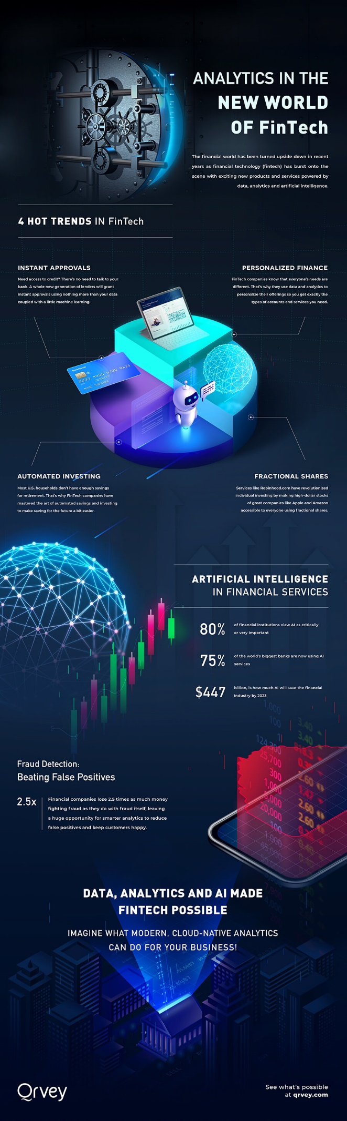

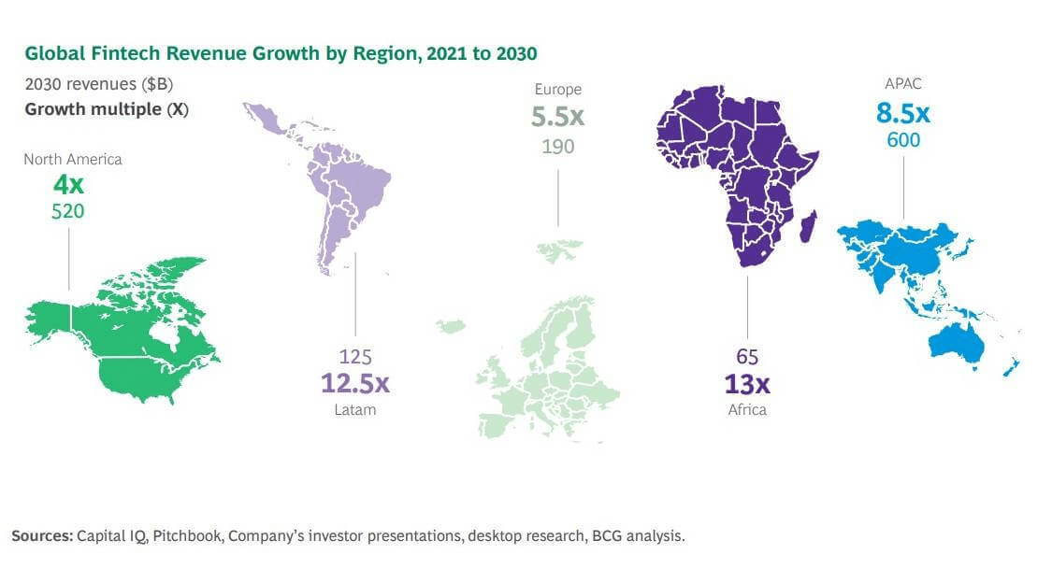

<https://technext24.com/2023/07/12/africa-lead-global-fintech-growth-65bn/>

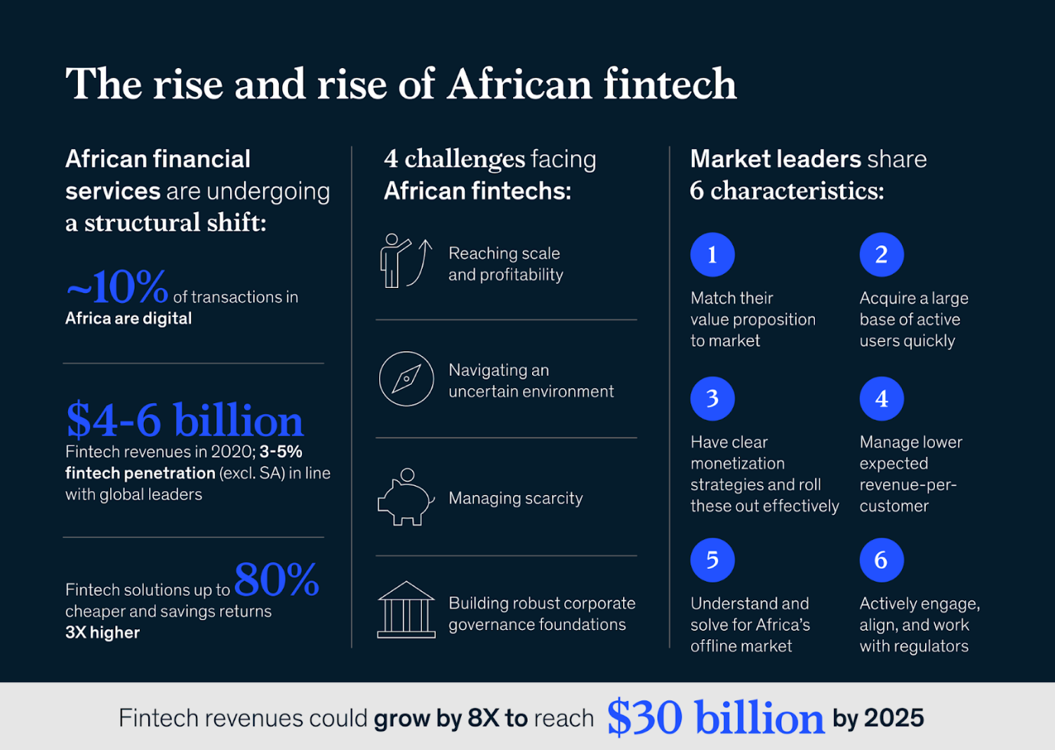

<https://technext24.com/2023/07/12/africa-lead-global-fintech-growth-65bn/>

<https://www.linkedin.com/posts/dichabe_theafricawewant-fintech-africafintech-activity-7069877522208894976-k-Wi/?originalSubdomain=bo>

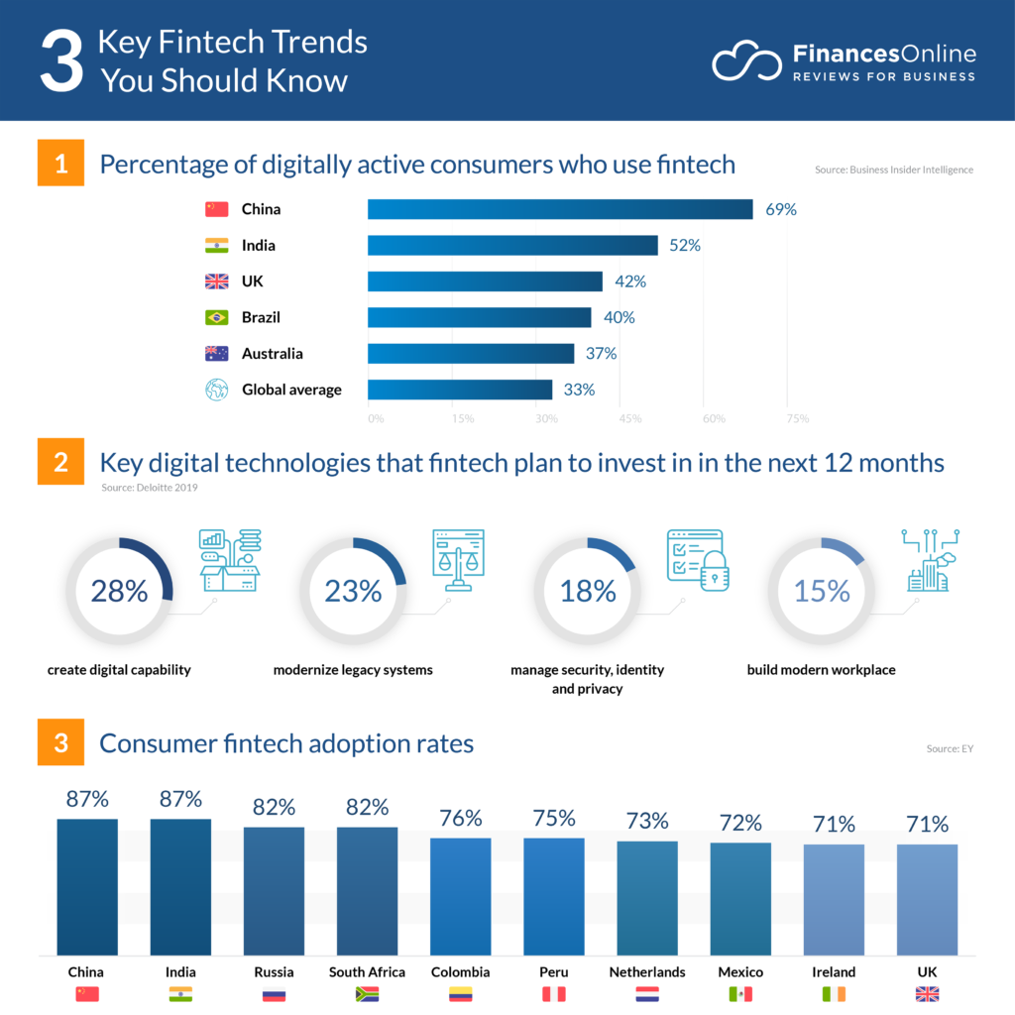

<https://financesonline.com/fintech-trends/>

<https://financesonline.com/fintech-trends/>

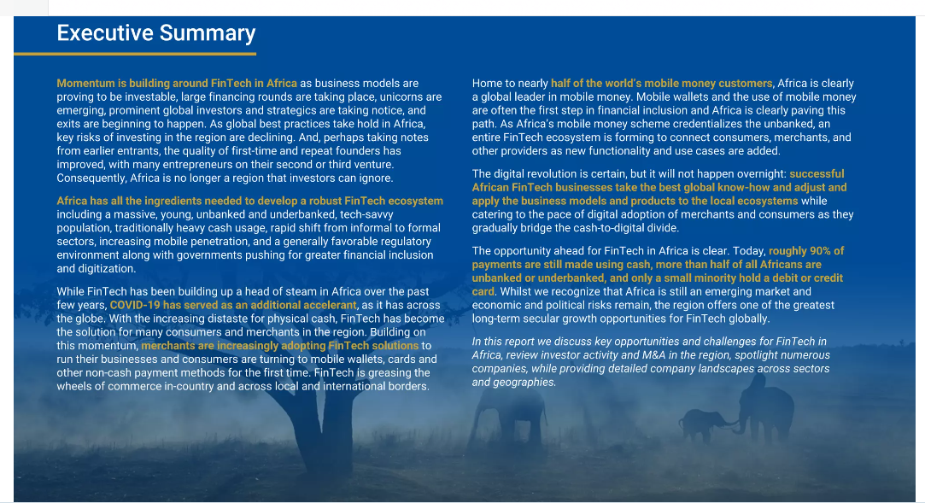

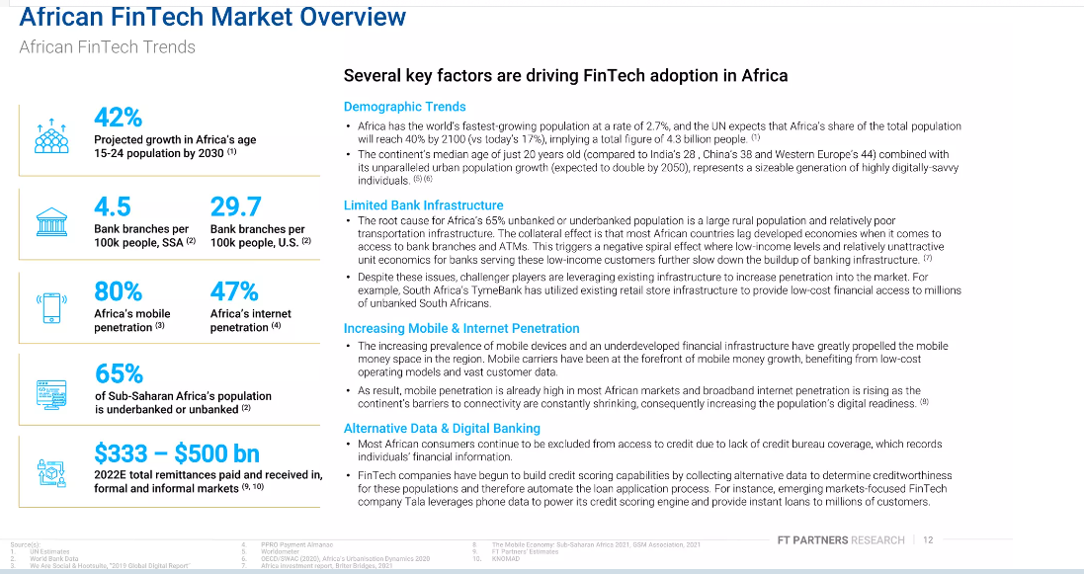

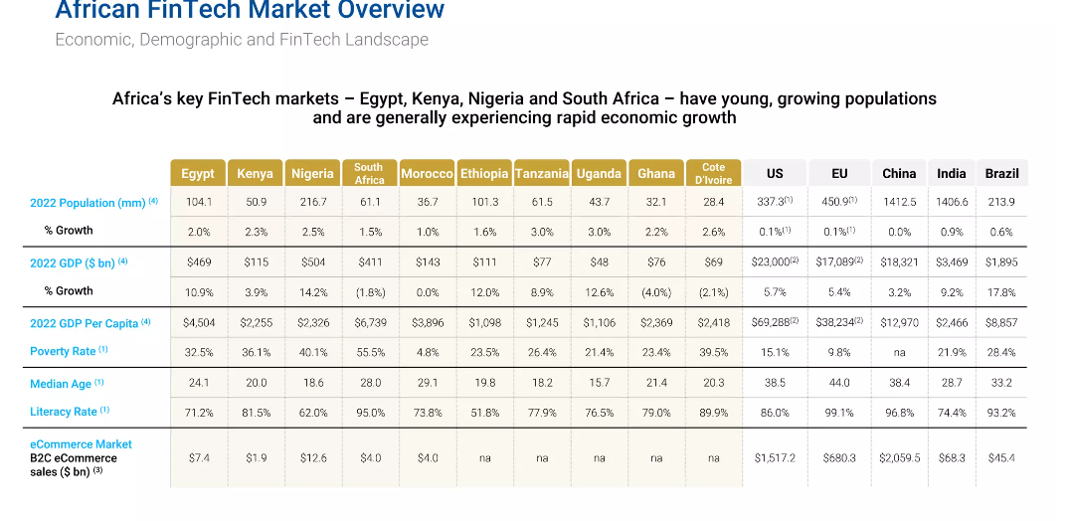

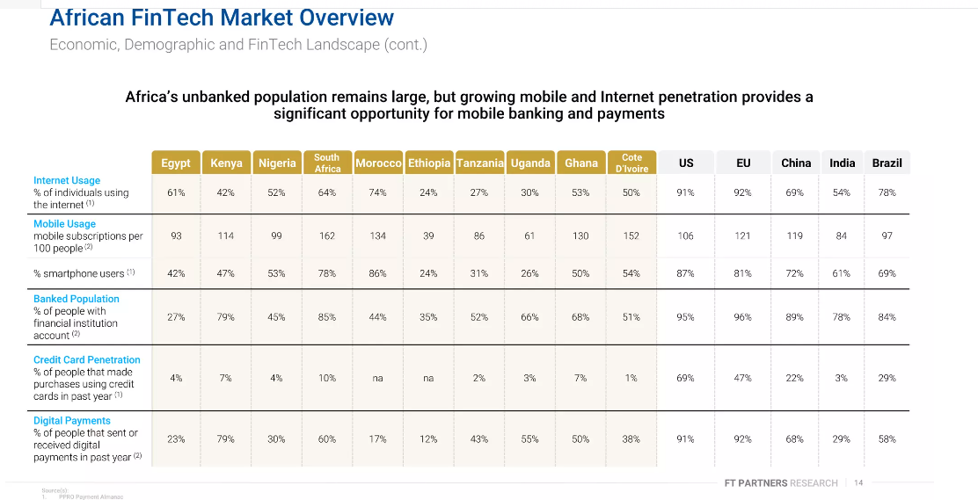

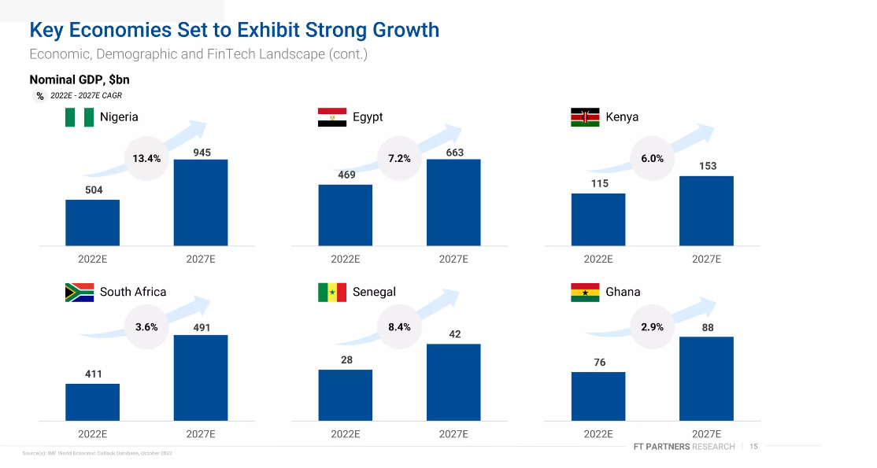

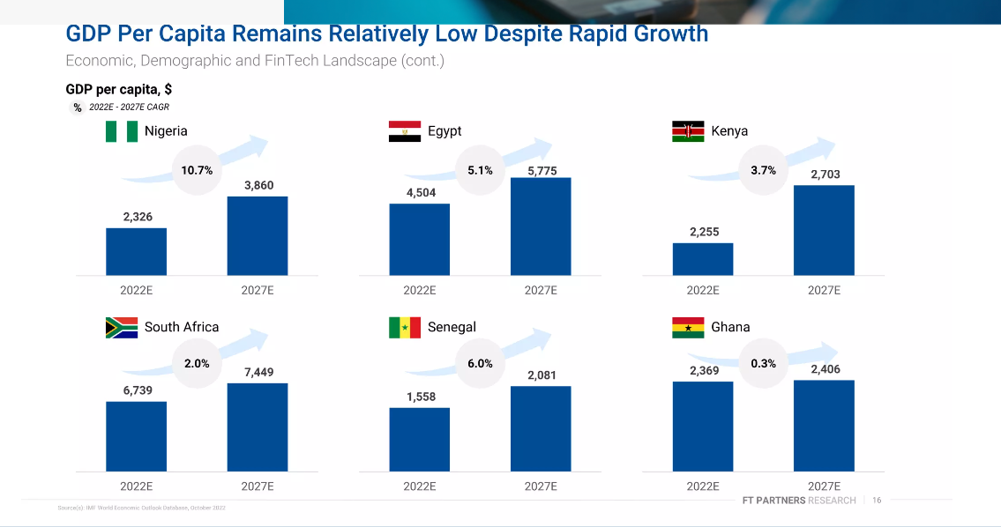

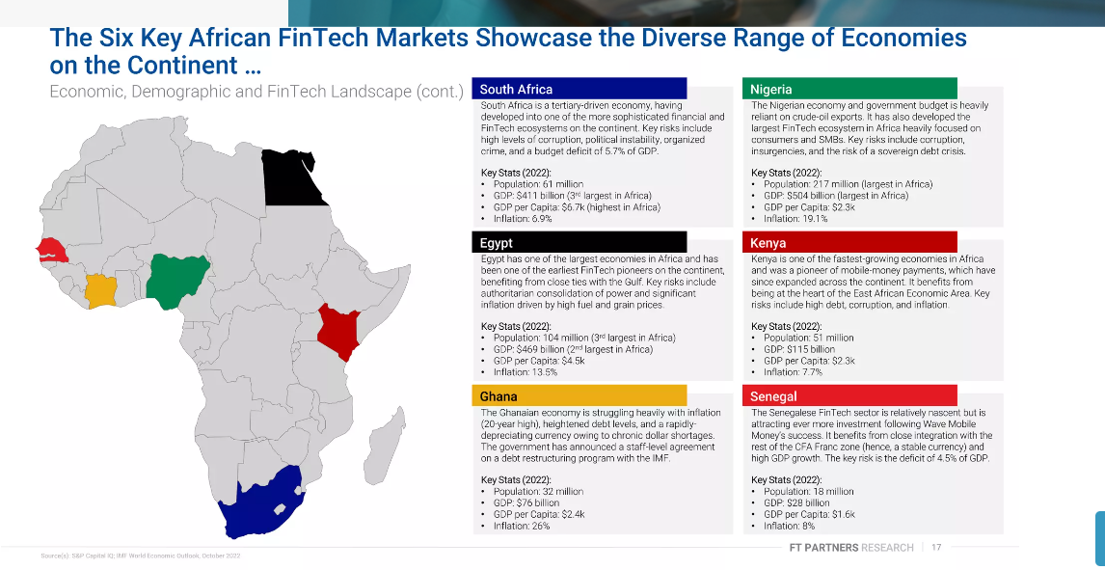

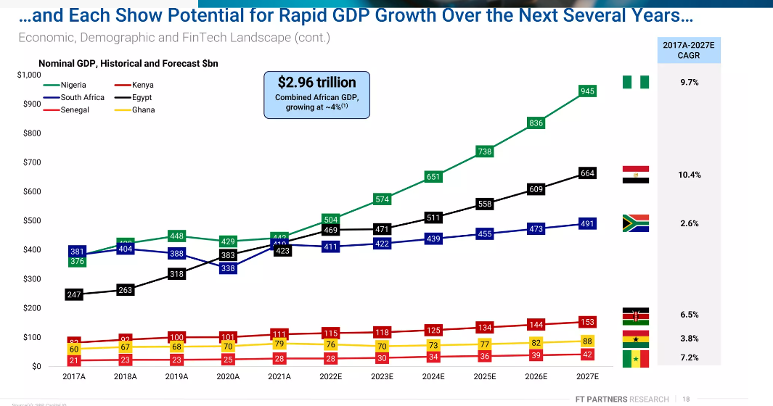

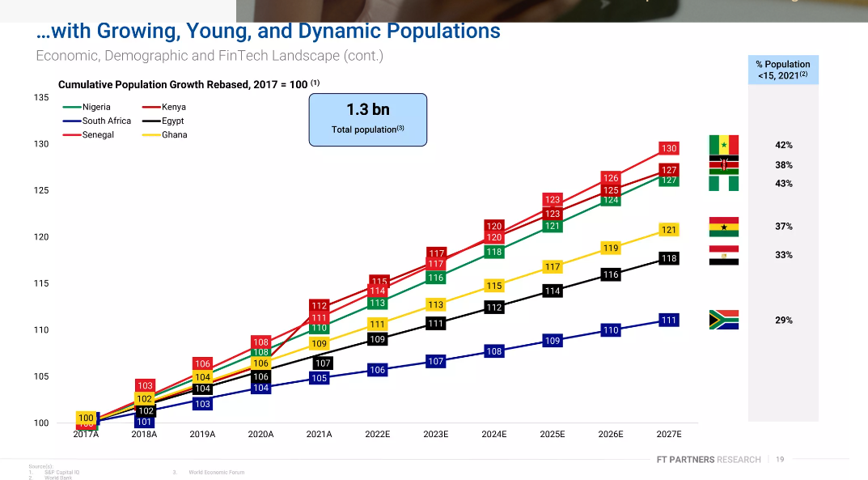

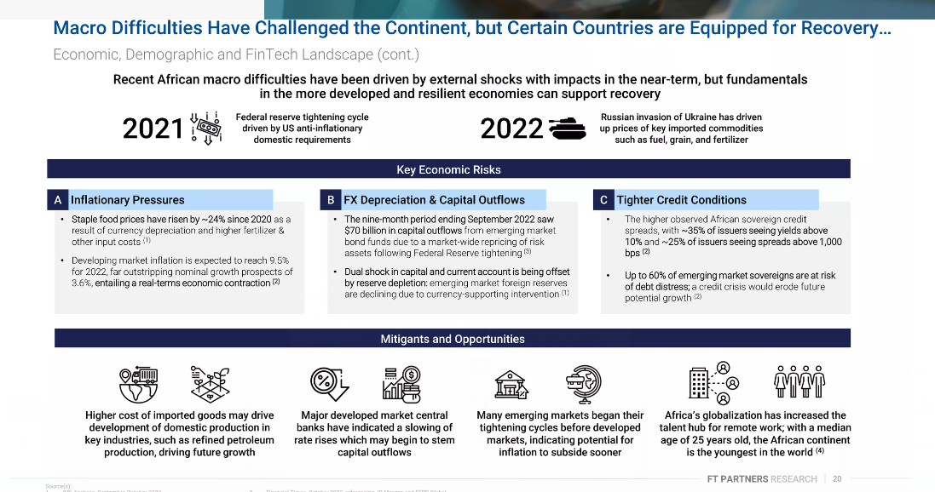

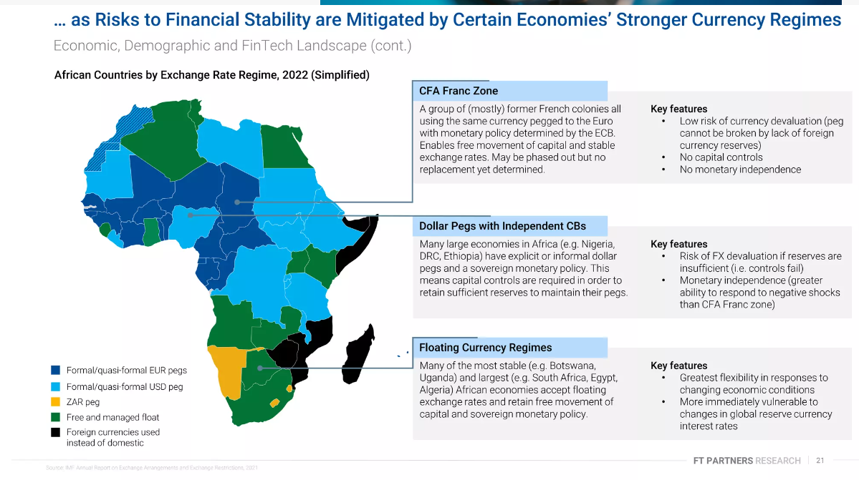

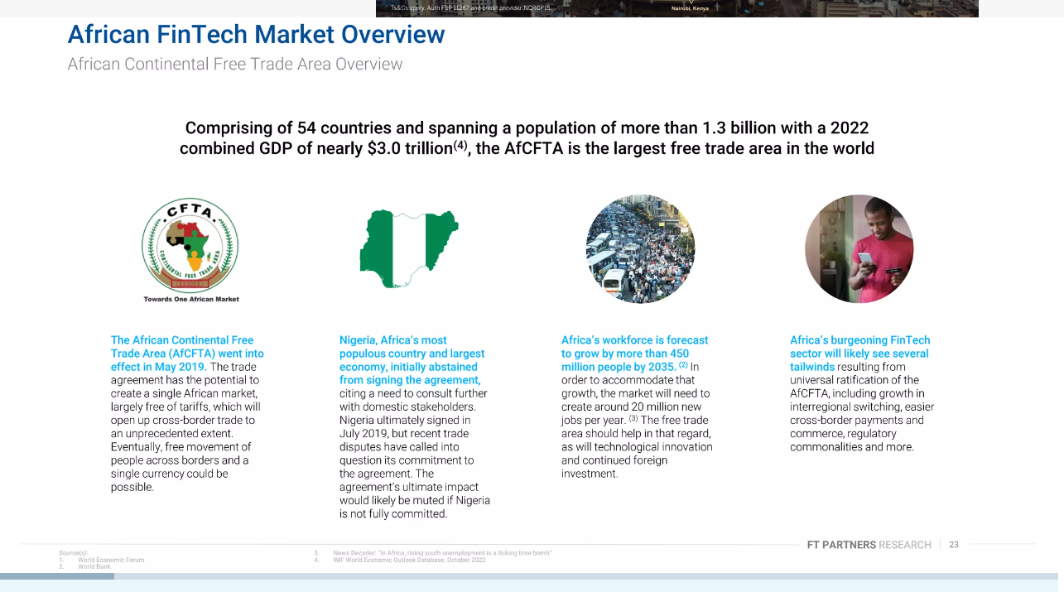

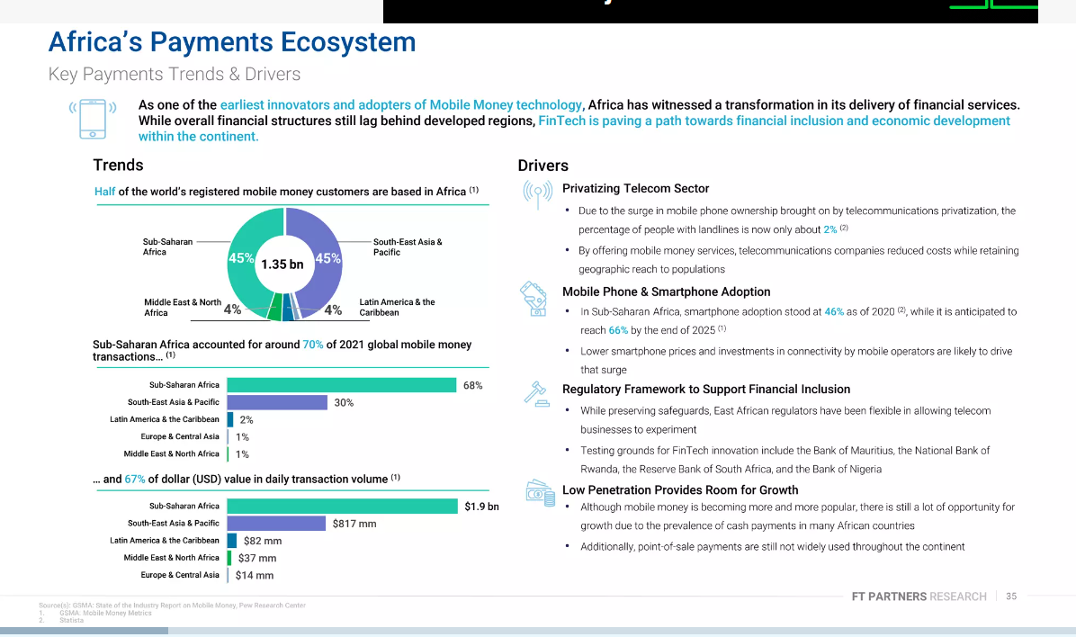

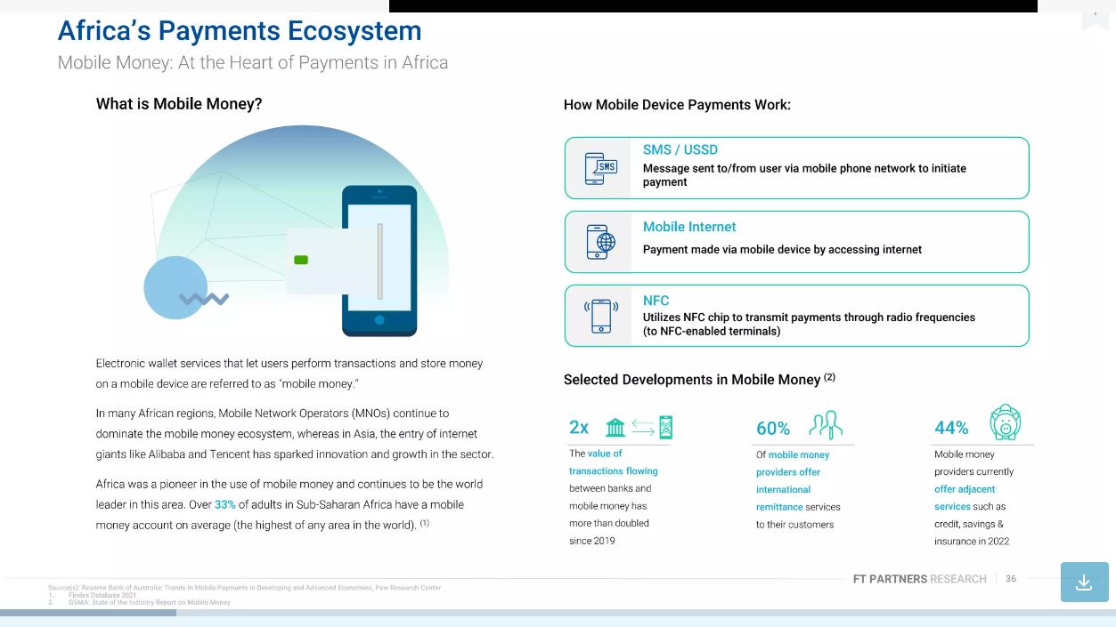

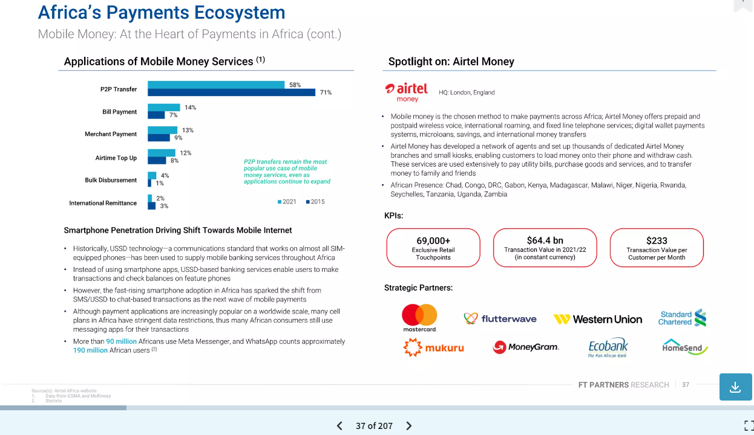

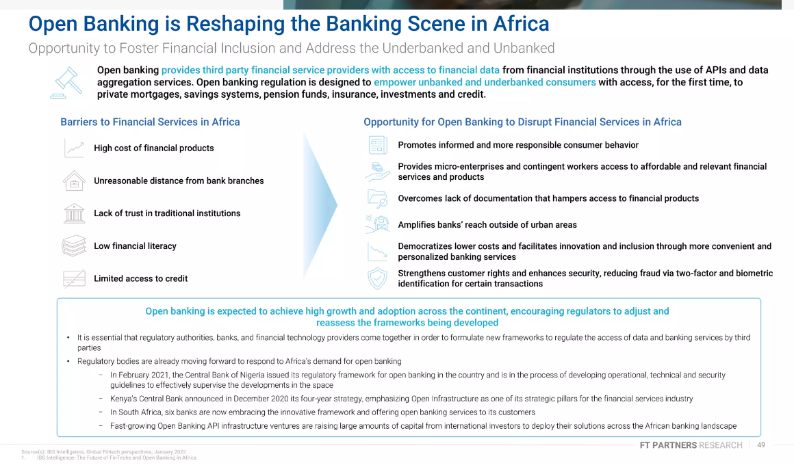

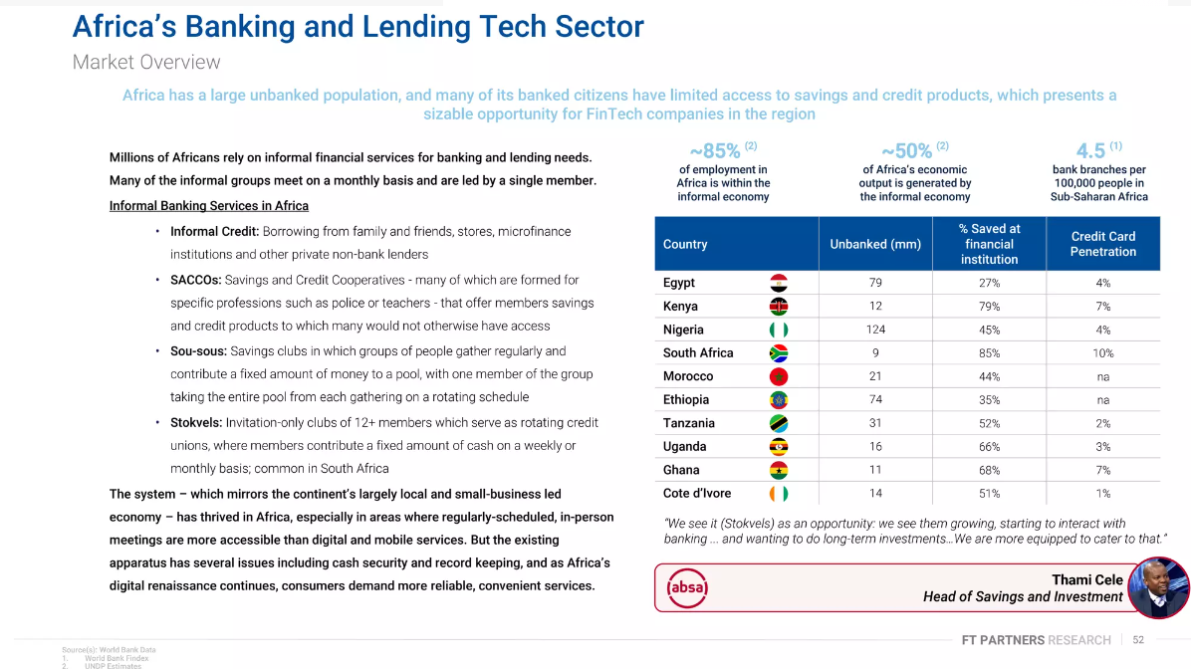

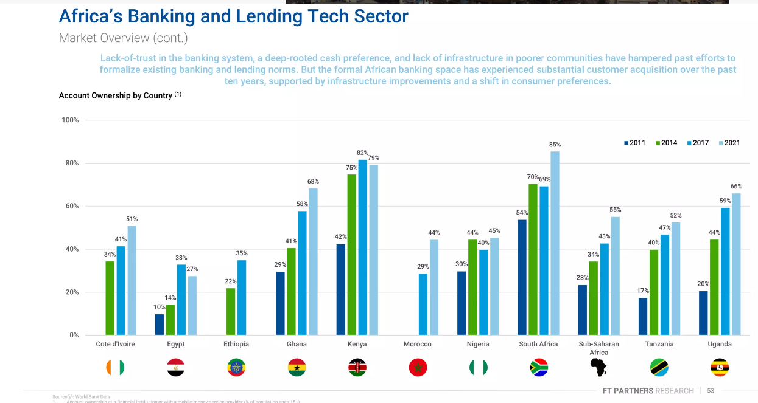

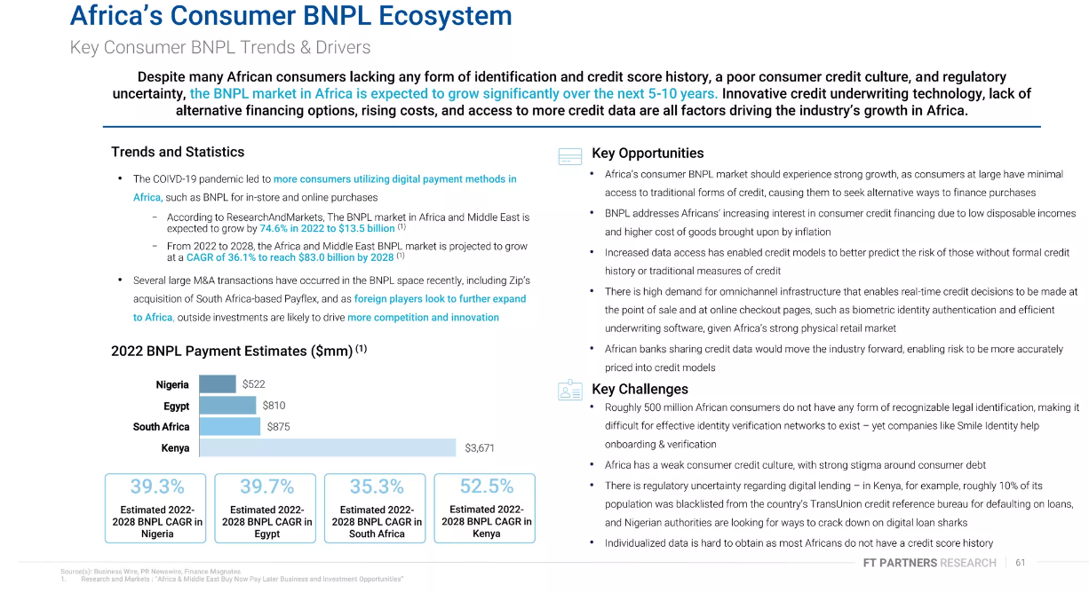

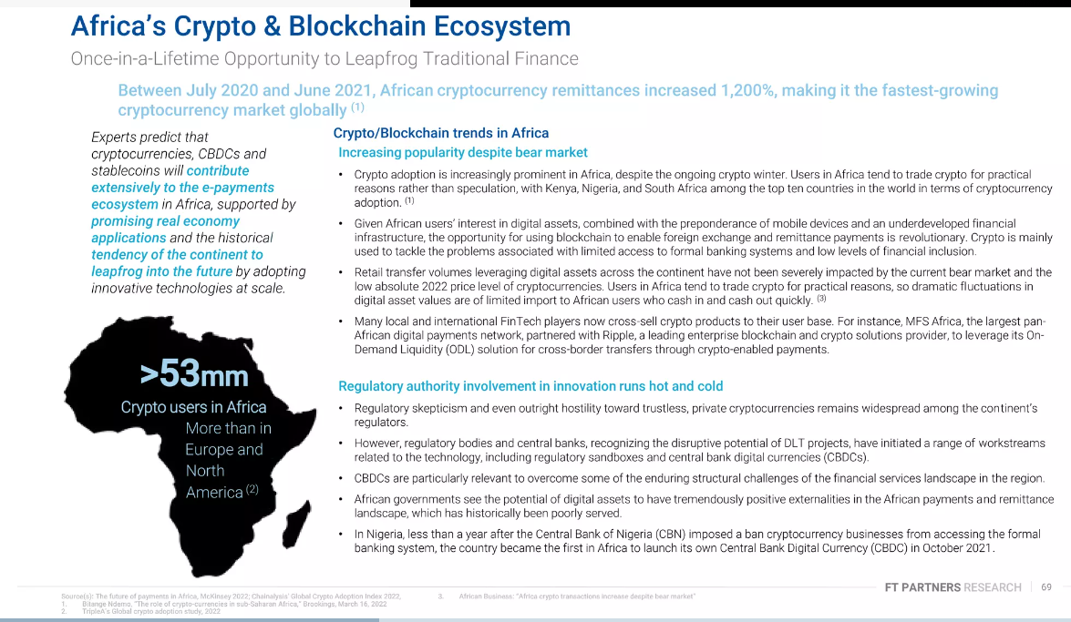

https://african.business/2023/06/technology-information/africas-fintech-market-to-reach-65bn-in-revenue-by-2030-says-new-study